Bash to scripting task -02
Tasks to Execute
case Scripts: 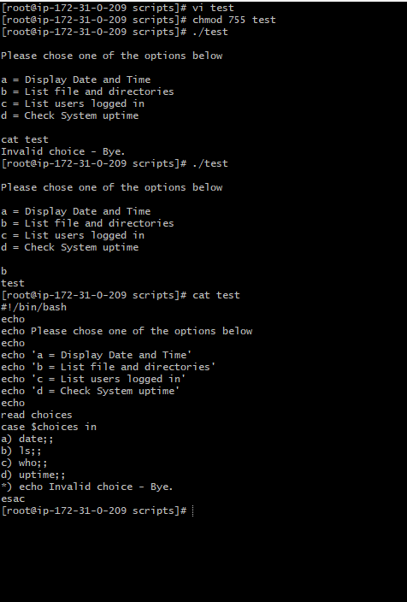
This script will look at your current day and tell you the state of the
backup
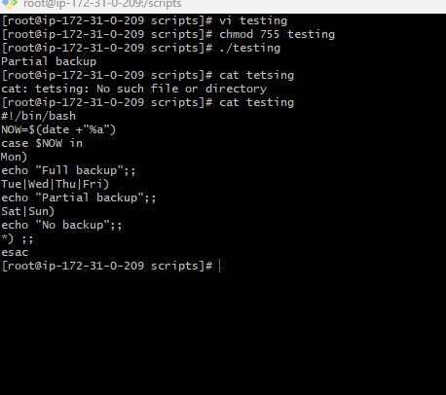
do-while Script
Script to run for a number of times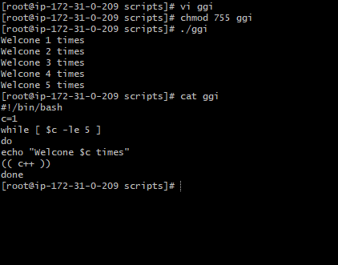
Script to run for a number of seconds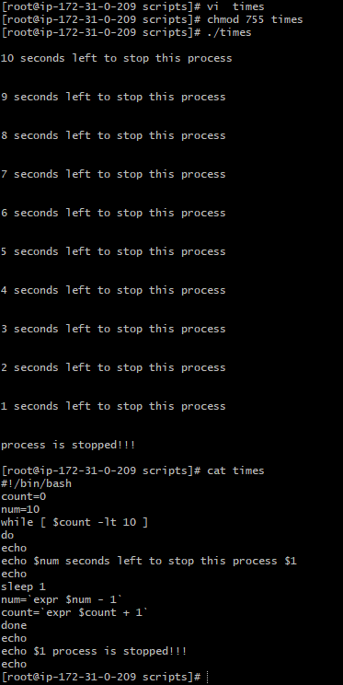
For loop Scripts:
Simple for loop output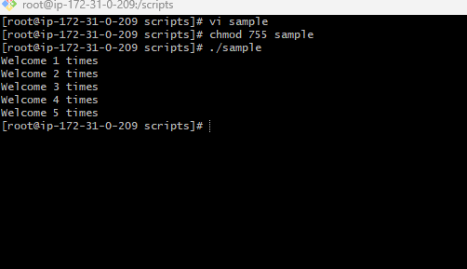
Simple for loop output: 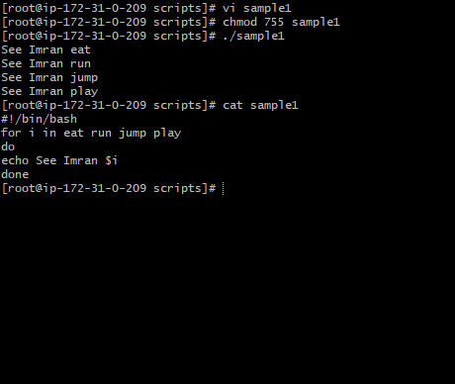
For loop to create 5 files named 1-5: 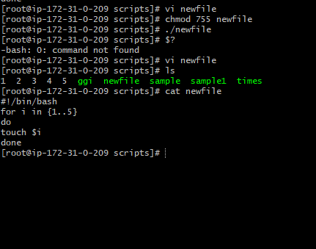
for loop to delete 5 files named 1-5: 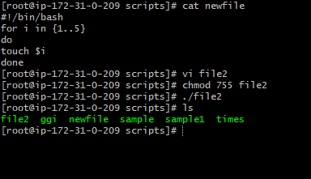
Specify days in for loop: 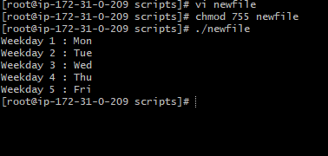
List all users one by one from /etc/passwd file: 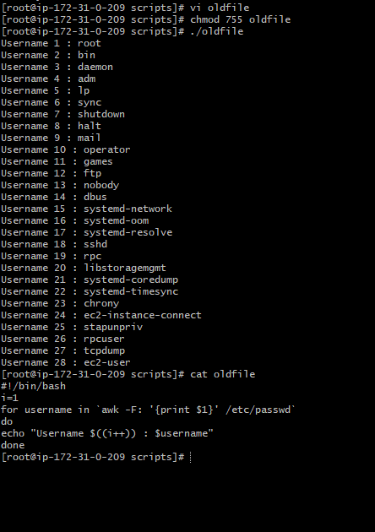
If-then Scripts:
Check the variable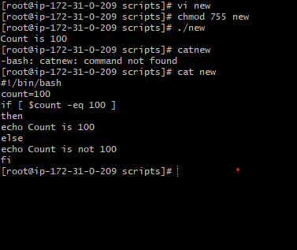
Check if a file error.txt exist
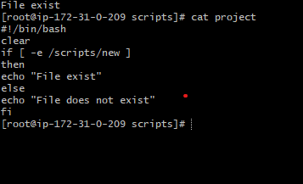
Check if a variable value is met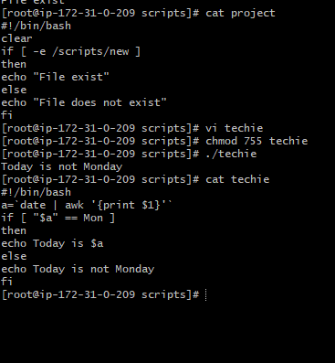
Check the response and then output